EXPERIMENT-6

AIM:

In this experiment we are going to prove that transistor as a switch.

THEORY:

Transistor switches can be used to switch a low voltage DC device (e.g.LED’s) ON or OFF by using a transistor in its saturated or cut-off state. When used as an AC signal amplifier, the transistors Base biasing voltage is applied in such a way that it always operates within its “active” region, that is the linear part of the output characteristics curves are used.However, both the NPN & PNP type bipolar transistors can be made to operate as “ON/OFF” type solid state switch by biasing the transistors Base terminal differently to that for a signal amplifier.

PROCEDURE:

• Basically, transistor is a type of semiconductor device. These devices consist of three numbers of terminals.

• The interaction among the two terminals will be insuch a way that two junctions are formed in it.

• These junctions and altogether terminals are responsible for the generation of the current either the current controlled or the respective voltage-controlled devices are designed.

• The main functionality of the transistor can be observed either by making it be used for amplification or to the basic application in the digital circuit of switching.

• The main reason behind using this transistor for the purpose of the switch is that the current at the base controls the current present at the collector directly.

• If the current at the base exceeds the minimum cut off value of

voltage, then the behaviour of the transistor is like a lose switch otherwise it will remain in switch condition.

• By the application of bias to the base of the transistor both the types in the bipolar junction transistor can be used as switches. • The areas at which the operation of the switch is preferred is either it should be completely in the region called saturation or the cut off operating region.

• The main theme behind using these regions is that switch mode should be completely ON or OFF.

MULTISIM:

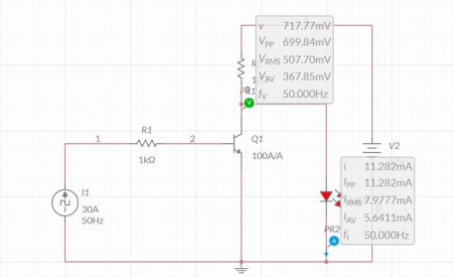

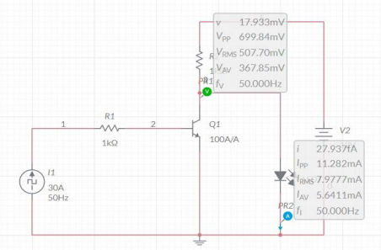

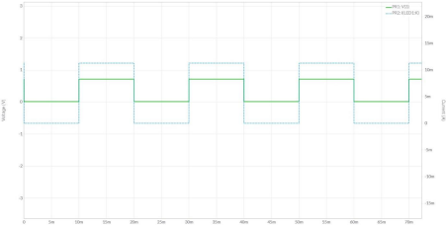

NAME: G R NITIN

ROLL NO: CB.EN.U4CYS21017